Capacitors and Calculus – Lenhart Physics

One of the fundamental principles of calculus is a process called integration. This principle is important to understand because it is manifested in the behavior of capacitance. Thankfully, there are more familiar physical systems which also manifest the process of integration, making it easier to comprehend.
If we introduce a constant flow of water into a cylindrical tank with water, the water level inside that tank will rise at a constant rate over time:
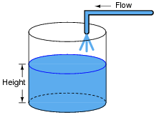
In calculus terms, we would say that the tank integrates water flow into water height. That is, one quantity (flow) dictates the rate-of-change over time of another quantity (height).
Like the water tank, electrical capacitance also exhibits the phenomenon of integration with respect to time. Which electrical quantity (voltage or current) dictates the rate-of-change over time of which other quantity (voltage or current) in a capacitance? Or, to re-phrase the question, which quantity (voltage or current), when maintained at a constant value, results in which other quantity (current or voltage) steadily ramping either up or down over time?
Reveal answer

