Capacitors

DC Electric Circuits

- Identify some of the different types of capacitors, and their characteristics.

- How are electrolytic capacitors constructed, and what is particularly noteworthy about their use?

- A capacitor has a label on it saying, “100 WVDC”. What does this label mean? What is the consequence of exceeding this rating?

- Capacitors may pose an electric shock hazard, even in unpowered circuits. Explain why.

- Very large capacitors (typically in excess of 1 Farad!) are often used in the DC power wiring of high-power audio amplifier systems installed in automobiles. The capacitors are connected in parallel with the amplifier’s DC power terminals, as close to the amplifier as possible, like this:
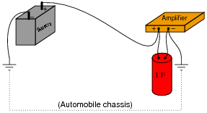
What is the purpose of having a capacitor connected in parallel with the amplifier’s power terminals? What benefit does this give to the audio system, overall?
- What does the abbreviation D.C. stand for in regards to Physics?

- What is the schematic symbol for a capacitor?

